Nepal College of Information Technology
UT Spring 2009

Subject : Electronic Circuits FM : 50
Program : ELX / CE Duration: 2 hrs

- (a) Draw CE amplifier circuit with emitter resistor. Draw its equivalent circuit and deduce the expressions of voltage and current gains. [10]

(b) What is frequency response of an amplifier? Explain low frequency response of RC coupled BJT transistor amplifier. [5]
- (a) "Darlington pair is super beta transistor." Comment and justify your answer with simple calculations.
2 (b) b) For the given circuit, find out [10]
c)
i. R_{in}(stage) of both transistors.
ii. The voltage gain of each stage
iii. Overall voltage gain
iv. Effective load resistance of both transistor
Q₁:r_{e1}=15 ohm, β₁=180
Q₂:r_{e2}=25 ohm, β₂=100
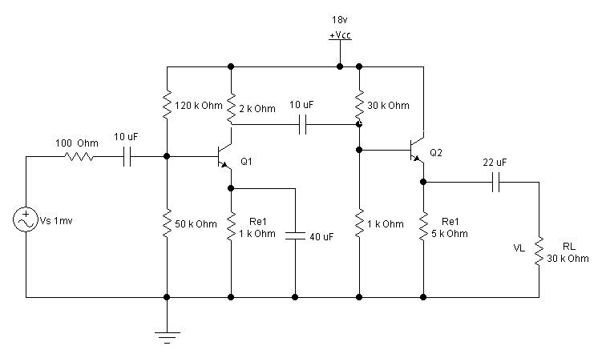

3 (a) How b) How can you differentiate between tuned and untuned amplifier. An RC coupled amplifier has a voltage gain of 100 in the range of 400 Hz to 25 KHz. On either side of these frequencies, the gain falls such that lower and upper corner frequencies are at 80 Hz and 40 KHZ respectively. Calculate the gain in dB at corner frequencies and bandwidth of the amplifier. [2+6]

[5]
3 (b)
b. For the given figure calculate output voltage in amplifier as shown. Let β=100. [8]

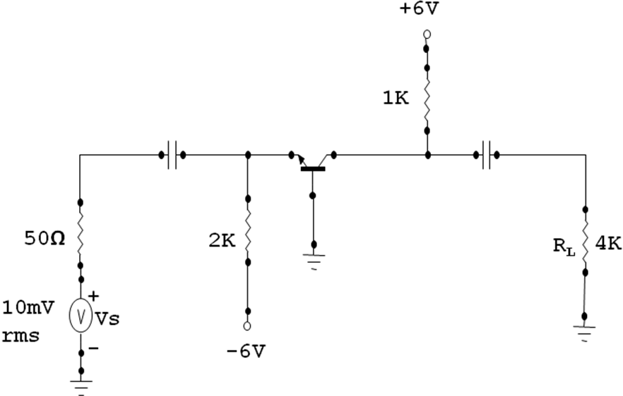
4. Write shot notes: [5*3]
- Distortion and types of distortions.
- Small signal amplifier, large signal amplifier and their differences.

